**PROJECT REPORT ON**

**“Motor speed and direction control using GSM modem”**

**Submitted in Partial Fulfillment of the Requirements**

**For the Award**

**Of**

**Degree of B. Tech**

**To**



**University,**

**Under the Guidance of**

**Submitted By:**

**\*Member1* *Member2\***

**\*Member3* *Member4\***



**Electronics and Communication Department**

**\*College Name\***

**CONTENTS**

hardware and software requirements

hardware used

JUMPER WIRES

Motor Driver IC L293d

DC BO Motors

GSM Shield

12V Power Supply

ARDUINO UNO

software used

ARDUINO SDK

working

1. **HARDWARE AND SOFTWARE REQUIREMENTS**
   1. **HARDWARE USED**

The Hardware which can be employed to implement the code generated in this project is listed below:

* JUMPER WIRES
* Motor Driver IC L293d
* DC BO Motors
* GSM Shield
* 12V Power Supply
* ARDUINO UNO
  + 1. **JUMPER WIRES**

A jump wire (also known as jumper, jumper wire, jumper cable, DuPont wire, or DuPont cable – named for one manufacturer of them) is an electrical wire or group of them in a cable with a connector or pin at each end (or sometimes without them – simply "tinned"), which is normally used to interconnect the components of a breadboard or other prototype or test circuit, internally or with other equipment or components, without soldering.

Individual jump wires are fitted by inserting their "end connectors" into the slots provided in a breadboard, the header connector of a circuit board, or a piece of test equipment.

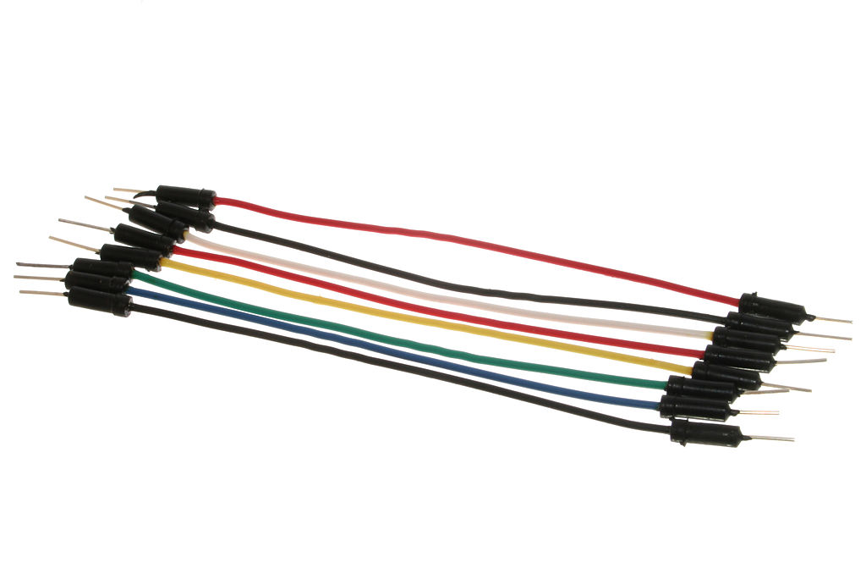

Figure Jumper wires

* + 1. **ARDUINO UNO**

Arduino is an open-source project that created microcontroller-based kits for building digital devices and interactive objects that can sense and control physical devices.

The project is based on microcontroller board designs, produced by several vendors, using various microcontrollers. These systems provide sets of digital and analog input/output (I/O) pins that can interface to various expansion boards (termed shields) and other circuits. The boards feature serial communication interfaces, including Universal Serial Bus (USB) on some models, for loading programs from personal computers. For programming the microcontrollers, the Arduino project provides an integrated development environment (IDE) based on a programming language named Processing, which also supports the languages C and C++.

The first Arduino was introduced in 2005, aiming to provide a low cost, easy way for novices and professionals to create devices that interact with their environment using sensors and actuators. Common examples of such devices intended for beginner hobbyists include simple robots, thermostats, and motion detectors.

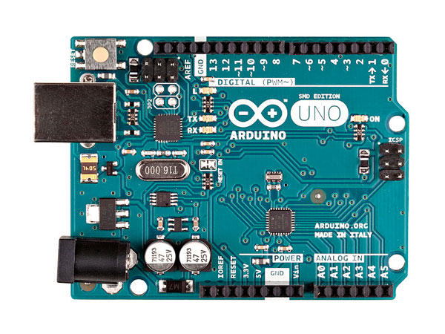

* + 1. **Motor Driver IC L293d**

L293D is a dual H-bridge motor driver integrated circuit (IC). Motor drivers act as current amplifiers since they take a low-current control signal and provide a higher-current signal. This higher current signal is used to drive the motors.

L293D contains two inbuilt H-bridge driver circuits. In its common mode of operation, two DC motors can be driven simultaneously, both in forward and reverse direction. The motor operations of two motors can be controlled by input logic at pins 2 & 7 and 10 & 15. Input logic 00 or 11 will stop the corresponding motor. Logic 01 and 10 will rotate it in clockwise and anticlockwise directions, respectively.

Enable pins 1 and 9 (corresponding to the two motors) must be high for motors to start operating. When an enable input is high, the associated driver gets enabled. As a result, the outputs become active and work in phase with their inputs. Similarly, when the enable input is low, that driver is disabled, and their outputs are off and in the high-impedance state.

* + 1. **DC BO Motor**

A DC motor is any of a class of rotary electrical machines that converts direct current electrical energy into mechanical energy. The most common types rely on the forces produced by magnetic fields. Nearly all types of DC motors have some internal mechanism, either electromechanical or electronic, to periodically change the direction of current flow in part of the motor.

DC motors were the first type widely used, since they could be powered from existing direct-current lighting power distribution systems. A DC motor's speed can be controlled over a wide range, using either a variable supply voltage or by changing the strength of current in its field windings. Small DC motors are used in tools, toys, and appliances. The universal motor can operate on direct current but is a lightweight motor used for portable power tools and appliances. Larger DC motors are used in propulsion of electric vehicles, elevator and hoists, or in drives for steel rolling mills. The advent of power electronics has made replacement of DC motors with AC motors possible in many applications.

* + 1. **GSM shield Sim900a**

The SIM900 GSM/GPRS Shield provides you a way to use the GSM cell phone network to receive data from a remote location. The shield allows you to achieve this via any of the three methods:

* Short Message Service
* Audio
* GPRS Service

The GPRS Shield is compatible with all boards which have the same form factor (and pinout) as a standard Arduino Board. The GPRS Shield is configured and controlled via its UART using simple AT commands. Based on the SIM900 module from SIMCOM, the GPRS Shield is like a cell phone. Besides the communications features, the GPRS Shield has 12 GPIOs, 2 PWMs and an ADC.

* + 1. **12 V Power Supply**

A power supply is an electrical device that supplies electric power to an electrical load. The primary function of a power supply is to convert electric current from a source to the correct voltage, current, and frequency to power the load. As a result, power supplies are sometimes referred to as electric power converters. Some power supplies are separate standalone pieces of equipment, while others are built into the load appliances that they power. Examples of the latter include power supplies found in desktop computers and consumer electronics devices. Other functions that power supplies may perform include limiting the current drawn by the load to safe levels, shutting off the current in the event of an electrical fault, power conditioning to prevent electronic noise or voltage surges on the input from reaching the load, power-factor correction, and storing energy so it can continue to power the load in the event of a temporary interruption in the source power (uninterruptible power supply).

* 1. **SOFTWARE USED**
* **Arduino IDE**

The Arduino Integrated Development Environment - or Arduino Software (IDE) - contains a text editor for writing code, a message area, a text console, a toolbar with buttons for common functions and a series of menus. It connects to the Arduino and Genuino hardware to upload programs and communicate with them.

1. Arduino Link  
 <https://www.arduino.cc/download_handler.php>

2. Wifi Link(esp8266 setup link)

<http://www.instructables.com/id/How-to-Install-ESP8266-Into-Arduino-IDE/>

* **WORKING OF THE PROJECT**

Device receives the commands from the user by SMS to control the direction and speed of the motor.

Commands-

To turn on the motor - /motor on/ ,

To turn off the motor - /motor off/ ,

other commands for speed control

* SCHEMATIC

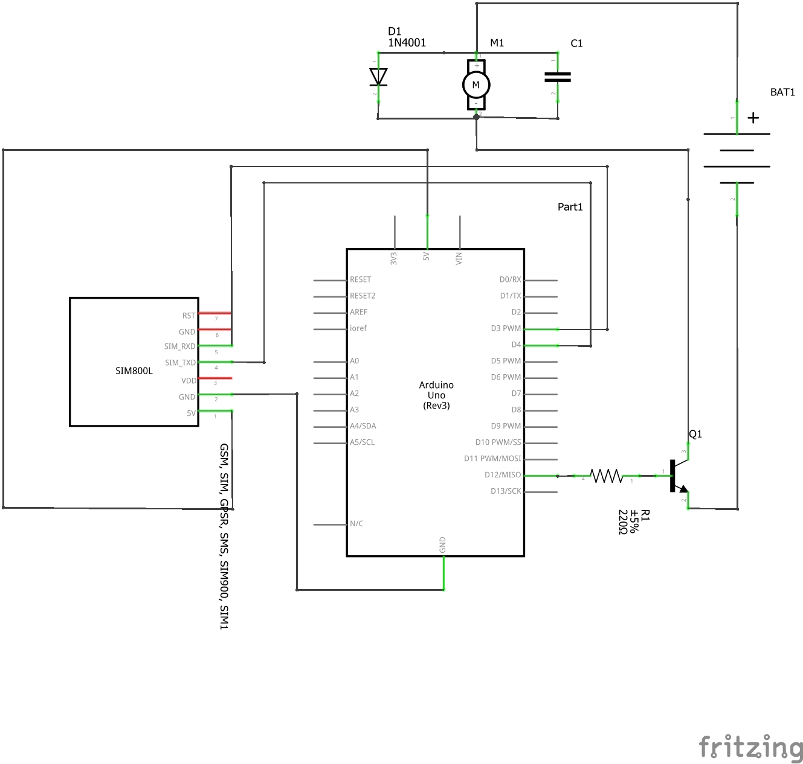

* CIRCUIT DIAGRAM

